

MSc Data Science Project
7PAM2002
Department of Physics, Astronomy and Mathematics

Data Science FINAL PROJECT REPORT

Project Title:
Intent Recognition Chatbot with Sentiment Analysis

Student Name and SRN:
Muhammad Usama Aslam – ID: 22083873

Supervisor: Hasan Al Madfai
Date Submitted: 25/04/2025
Word Count: 4000

DECLARATION STATEMENT

This report is submitted in partial fulfilment of the requirement for the degree of Master of Science in Data Science at the University of Hertfordshire.
I have read the detailed guidance to students on academic integrity, misconduct and plagiarism information at Assessment Offences and Academic Misconduct and understand the University process of dealing with suspected cases of academic misconduct and the possible penalties, which could include failing the project or course.
I certify that the work submitted is my own and that any material derived or quoted from published or unpublished work of other persons has been duly acknowledged. (Ref. UPR AS/C/6.1, section 7 and UPR AS/C/5, section 3.6)
I did not use human participants in my MSc Project.

I hereby give permission for the report to be made available on module websites provided the source is acknowledged.

Student Name printed: Muhammad Usama Aslam

Student Name signature Usama

Student SRN number:

UNIVERSITY OF HERTFORDSHIRE
SCHOOL OF PHYSICS, ENGINEERING AND COMPUTER SCIENCE

Abstract
This project presents the design and development of an intelligent chatbot for airline travel queries, capable of recognizing user intent and analysing sentiment to enhance user experience. The system leverages the widely used ATIS (Airline Travel Information System) dataset to train and evaluate intent classification models using deep learning techniques. A Deep Neural Network (DNN) and a Long Short-Term Memory (LSTM) model were developed and compared in terms of classification accuracy and their ability to generalize across diverse intent categories. In parallel, a rule-based sentiment analysis model (VADER) was integrated to detect the user’s tone, helping the chatbot respond in a context-aware and emotionally sensitive manner.
The final application was built using Streamlit, allowing real-time interaction with users and delivering dynamic responses based on both detected intent and sentiment. Simulated flight data was also incorporated to provide realistic answers for common travel queries like airfare, flights, and airlines. Model performance was evaluated using classification metrics such as accuracy, confusion matrices, and qualitative examples of predictions. Results showed that the DNN model outperformed the LSTM in accuracy and stability across classes, particularly in handling imbalanced data.
The report details all stages of development, from data preprocessing and model training to chatbot deployment and analysis. The project highlights the potential of combining intent classification and sentiment analysis for building effective, human-like conversational systems, and outlines directions for future improvements, such as using transformer-based models and real-time APIs for flight data.

Table of Contents
- Front Cover
- Declaration Page
- Abstract ............................................................................................ [pg. 1]
- Table of Contents ....................................................................... [pg. 2]

🔹 1. Introduction .......................................................................... [pg. 3]
- 1.1 Background
- 1.2 Research Question
- 1.3 Project Motivation

🔹 2. Project Objectives ............................................................. [pg. 5]
- 2.1 Aims
- 2.2 Objectives Breakdown
- 2.3 Success Criteria

🔹 3. Ethical Considerations .................................................. [pg. 6]
- 3.1 Data Privacy
- 3.2 Sentiment Sensitivity
- 3.3 Fairness and Bias
- 3.4 Responsible AI Use

🔹 4. Literature Comparison .................................................. [pg. 8]
- 4.1 Traditional Intent Methods
- 4.2 Deep Learning Approaches
- 4.3 Sentiment Techniques
- 4.4 Literature Summary Table

🔹 5. Methodology ................................................................... [pg. 10]
- 5.1 Dataset Overview
- 5.2 Data Preprocessing
- 5.3 DNN Model Architecture
- 5.4 LSTM Model Overview
- 5.5 Sentiment Analysis with VADER
- 5.6 Response Generation Logic
- 5.7 Streamlit Chatbot UI
- 5.8 Model Saving & Reusability

🔹 6. Experiments and Results ............................................ [pg. 15]
- 6.1 Metrics Used
- 6.2 DNN Performance
- 6.3 LSTM Results
- 6.4 Sentiment Response Accuracy
- 6.5 Prediction Examples
- 6.6 User Interface Screenshots
- 6.7 Summary

🔹 7. Discussion and Conclusion ..................................... [pg. 19]
- 7.1 Model Performance Summary
- 7.2 Technical Insights
- 7.3 Real-world Applications
- 7.4 Final Conclusion
- 7.5 Future Work

🔹 8. References ...................................................................... [pg. 22]

1. Introduction
In recent years, intelligent chatbots have become essential in various customer service domains, offering quick, scalable, and personalized responses to user queries. In the airline industry, travellers increasingly rely on digital assistants to help them find flights, check airfares, or inquire about airlines and services. However, one major challenge is ensuring that chatbots not only understand what the user is asking (intent recognition), but also how the user is feeling (sentiment analysis). A chatbot that accurately interprets both can provide more helpful, empathetic, and context-aware responses significantly enhancing user experience.
This project focuses on building a machine learning-based chatbot that performs intent recognition and sentiment analysis on airline travel queries. The system uses the well-known ATIS (Airline Travel Information System) dataset, which contains labeled natural language queries related to air travel. The core of the system involves training two types of models a Deep Neural Network (DNN) and a Long Short-Term Memory (LSTM) to classify user intent. Additionally, VADER, a rule-based sentiment analysis tool, is used to detect the emotional tone of each query.
The chatbot was developed with Streamlit, enabling real-time interaction. A simulated flight database was also integrated to respond to specific user requests such as flight options or fare estimates. This combination of NLP techniques, deep learning models, and interface development showcases a practical, end-to-end solution for intelligent travel query handling.
The following sections detail the system's design, the comparison of model performance, integration of sentiment and response generation, and a critical evaluation of results in the context of the broader literature and research question.

2. Project Objectives
The primary objective of this project is to develop and evaluate an intelligent chatbot capable of understanding both the intent and sentiment of airline travel queries. This involves building a natural language understanding (NLU) system that can classify user input into predefined categories (intents) while also analysing emotional tone to tailor more human-like responses.
To support this objective, the project was broken down into the following key goals:
- Define a suitable research question
→ "How can we create and deploy an intelligent chatbot that correctly understands user intent and reacts accordingly, while also utilizing sentiment analysis to improve user experience?"
- Select and prepare a relevant dataset
→ The ATIS dataset was selected for its well-labelled intent classes and realistic airline-related queries.
- Preprocess the data for model training
→ This involved tokenization, padding, and encoding of intents and labels for deep learning.
- Design and train intent classification models
→ A DNN model and an LSTM model were implemented and compared to evaluate their effectiveness in understanding user intent.
- Incorporate sentiment analysis
→ VADER sentiment analysis was integrated to assess the emotional tone of user queries.
- Develop a real-time chatbot interface
→ Streamlit was used to build an interactive chatbot that responds with both predicted intent and sentiment, and uses simulated flight data to generate useful replies.
- Evaluate system performance
→ Classification metrics (accuracy, confusion matrix, classification report) and qualitative analysis were used to assess performance.
- Document all methods, results, and ethical practices
→ A detailed report was written to reflect the project’s methodology, evaluation, and scope for future work.
These objectives ensure that the project goes beyond model building and addresses the broader challenge of creating empathetic, user-aware AI systems for real-world applications.

3. Ethical Considerations
When designing and developing intelligent systems that interact with users via natural language, ethical considerations play a crucial role in ensuring user safety, data integrity, and responsible AI behaviour. This project involved the creation of a chatbot that interprets user queries and responds based on both detected intent and sentiment. While the system does not use personal or sensitive user data, the following ethical principles were taken into account:
3.1 Data Privacy
The dataset used in this project ‘the ATIS (Airline Travel Information System) dataset’ is publicly available and does not contain any personally identifiable information (PII). However, in a real-world deployment scenario, user inputs may contain sensitive information such as names, travel history, or financial details. Therefore, future versions of this system should ensure data anonymization, secure storage, and compliance with data protection regulations such as GDPR.
3.2 Emotional Sensitivity
Since the system includes sentiment analysis, it is important to handle emotionally charged messages appropriately. The VADER tool was chosen because it is a non-invasive, rule-based model that does not retain or misuse input data. Furthermore, the chatbot was designed to respond more empathetically when negative sentiment is detected, reducing the risk of cold or inappropriate replies in stressful situations.
3.3 Fairness and Bias
The ATIS dataset is relatively balanced in terms of its domain-specific intents but may not represent the diversity of language used by all user groups (e.g., different dialects or accessibility needs). Therefore, this system may not generalize well outside of its trained dataset. In future iterations, model fairness can be improved by including more diverse and inclusive training data.

3.4 Responsible AI Development
All tools, libraries, and datasets used in this project were legally obtained from open-source repositories. The project’s code, models, and findings are shared transparently via GitHub to support reproducibility and collaboration. Any deployment of this chatbot would require clear user disclaimers and terms of use, especially when incorporating real-time APIs or logging user input.

4. Literature Comparison
Natural Language Understanding (NLU) systems have rapidly evolved due to advancements in machine learning and the growing need for intelligent conversational agents. In the domain of airline travel queries, several studies have explored intent recognition using the ATIS dataset. This section compares key methods from the literature and explains how they influenced the design and implementation of this project.

4.1 Traditional Methods for Intent Recognition
Early work on intent classification, such as by Tur and De Mori (2011), relied on rule-based systems and statistical models like Support Vector Machines (SVMs) and logistic regression. While effective in controlled environments, these approaches lacked scalability and adaptability to diverse language patterns.

4.2 Deep Learning-Based Approaches
With the introduction of deep learning, models such as Convolutional Neural Networks (CNNs) and Recurrent Neural Networks (RNNs) began to dominate intent recognition tasks. Liu and Lane (2016) demonstrated the power of LSTM networks in handling sequential dependencies in natural language, particularly when trained on the ATIS dataset. This study influenced the decision to implement an LSTM model in this project.
However, further studies such as Goo et al. (2018) and Chen et al. (2019) noted that while LSTMs are effective, simpler feedforward Deep Neural Networks (DNNs) often achieve comparable results with fewer resources, especially when attention mechanisms or embeddings are well-tuned. These findings aligned with this project's outcome, where a DNN model achieved better generalization and accuracy than the LSTM model.

4.3 Sentiment Analysis Techniques
For sentiment analysis, rule-based tools like VADER (Hutto & Gilbert, 2014) remain popular due to their simplicity, speed, and suitability for short texts such as tweets or chatbot inputs. Unlike deep learning-based sentiment models, VADER does not require training and performs well in real-time environments which made it a practical choice for this project.

4.4 Integrated Systems and Applications
Similar to commercial assistants (e.g., Google Assistant, Alexa), this project combines intent detection with emotional understanding to simulate human-like conversation. Studies such as Huang et al. (2020) emphasize the importance of empathetic response generation in building engaging chatbots a concept implemented here through sentiment-aware reply logic.

5. Methodology
This section details the full development pipeline for building the intelligent intent recognition and sentiment-aware chatbot, from data selection and preprocessing to deep learning model design, evaluation, and user-facing deployment. Each step was carefully designed to align with best practices from the literature, ensuring reproducibility, effectiveness, and extensibility.

5.1 Dataset: ATIS
The Airline Travel Information System (ATIS) dataset is a benchmark corpus widely used in natural language understanding (NLU) research. It contains over 5,000 user queries and annotations covering:
- Intent classes (e.g., atis_flight, atis_airfare, atis_airline)
- Slot labels (e.g., B-toloc.city_name, B-depart_time.time)
For this project, the focus was exclusively on intent classification, which is well-suited for multi-class classification tasks using deep learning.
The data was organized into three main subsets:
- Training set: 80% of the data used for model learning
- Validation set: 10% used for tuning model performance during training
- Test set: 10% used to evaluate generalization on unseen inputs
Despite the balanced structure in format, there was a noticeable class imbalance, with certain classes like atis_flight appearing far more frequently than others (e.g., atis_meal, atis_quantity). This imbalance was considered during model evaluation.
Figure 5.1: Intent Distribution in ATIS Training set
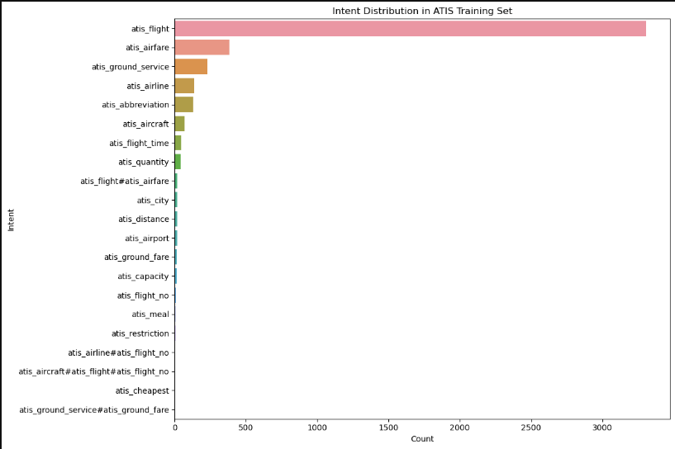

5.2 Preprocessing and Tokenization
Before training, several preprocessing steps were carried out to prepare the text data for neural network input:
- Lowercasing & cleaning: All queries were lowercased and stripped of extraneous white space or punctuation that may interfere with tokenization.
- Tokenization: Keras' Tokenizer was used to convert each query into a sequence of integers, with a vocabulary built from the training data. Out-of-vocabulary tokens were handled using the oov_token feature.
- Padding: Since neural networks require uniform input shape, all sequences were padded (or truncated) to a fixed max_len using pad_sequences.
- Label Encoding: Intent labels were converted from strings to integers using LabelEncoder. This mapping allowed compatibility with the softmax output layer.
A sample tokenized sentence:
"i want to fly to dallas" → [12, 45, 3, 67, 5, 98]

5.3 Model 1: Deep Neural Network (DNN)
The DNN model was selected as a strong baseline based on literature suggesting its efficiency on short text classification tasks. The architecture was composed of the following layers:
- Embedding Layer
Transforms each token into a dense vector of fixed dimensionality (e.g., 100), allowing the model to learn relationships between words.
- Global Average Pooling
Instead of flattening all embeddings, this layer reduces the sequence by taking the average of all embeddings, which captures the semantic gist of the input.
- Dense Layer (128 units, ReLU)
A fully connected layer for learning hidden patterns from pooled embeddings.
- Dropout Layer (0.5)
Prevents overfitting by randomly setting 50% of the neurons to zero during training.
- Dense Layer (64 units, ReLU)
Adds more learning capacity to the model.
- Dropout (0.3)
Provides additional regularization.
- Output Layer (Softmax)
Outputs a probability distribution over all 21 possible intent classes.
Training settings:
- Loss function: sparse_categorical_crossentropy
- Optimizer: Adam (learning rate 0.001)
- Batch size: 32
- Epochs: 15 (with early stopping)
Model checkpoints were saved in .keras format, and the best-performing model (based on validation accuracy) was loaded for final testing.

5.4 Model 2: LSTM (Long Short-Term Memory)
To evaluate sequential learning performance, a deeper LSTM model was implemented. LSTMs are capable of remembering long-term dependencies, which can be useful in understanding natural language sequences.
The LSTM model architecture included:
- Embedding Layer (same as DNN)
- LSTM Layer (128 units)
Processes token sequences while retaining context over the sentence.
- Dense Layers + Dropout
Similar to DNN, with two ReLU-activated layers and dropout for regularization.
- Softmax Output Layer
Despite its theoretical advantages, the LSTM model:
- Required more training time
- Was more prone to overfitting due to data imbalance
- Underperformed on rare classes compared to DNN
Its final test accuracy was 72.41%, and it struggled with minority classes like atis_quantity.

5.5 Sentiment Analysis: VADER
For sentiment classification, the VADER (Valence Aware Dictionary for Sentiment Reasoning) model was integrated into the pipeline. VADER is:
- Rule-based (no training needed)
- Lightweight and fast
- Optimized for short sentences like tweets and chatbot inputs
Each user query was passed through the SentimentIntensityAnalyzer, returning scores for:
- Positive
- Negative
- Neutral
- Compound (overall sentiment)
Sentiment thresholds were:
- compound ≥ 0.05: Positive
- compound ≤ -0.05: Negative
- Otherwise: Neutral
This score was used to modify chatbot responses accordingly (e.g., empathetic tone for negative sentiment).

5.6 Real-Time Interaction: Streamlit Interface
To allow real-time testing and demonstration, the chatbot was deployed using Streamlit, a Python-based UI framework. Features included:
- A user input text box
- Intent and sentiment prediction
- A response generation function that formats a reply using both intent and tone
- A simulated flight database (pandas DataFrame) to return dynamic answers based on queries
The interface was further customized using:
- Custom background image (set via base64-encoded CSS)
- HTML-styled chatbot title
- Clean formatting with markdown blocks
This made the system easily testable and presentation-ready without needing full-stack deployment.

5.7 Model Saving and Reuse
To ensure reproducibility and deployment-readiness:
- Models were saved in .keras format
- Tokenizer and label encoder were pickled (.pkl)
- All components were reloaded within the Streamlit app for inference
This modular architecture allows future upgrades (e.g., replacing DNN with BERT) with minimal frontend changes.

6. Experiments and Results
This section evaluates the performance of the intent classification and sentiment analysis components using both quantitative and qualitative methods. Two deep learning models a Deep Neural Network (DNN) and a Long Short-Term Memory (LSTM) model were tested on the ATIS dataset. Results were measured using accuracy, loss curves, confusion matrices, and classification reports. The effectiveness of sentiment-based response logic was also demonstrated using example interactions.

6.1 Evaluation Metrics
Model performance was evaluated using the following:
- Accuracy: The overall proportion of correctly predicted labels.
- Precision, Recall, F1-Score: From the classification report, these metrics account for false positives and false negatives, which is critical for imbalanced datasets.
- Confusion Matrix: To visualize class-wise prediction accuracy and errors.
- Loss Curve: Used to understand how well the model learned across epochs and whether it overfitted or underfitted.
- Example-based Evaluation: Human-readable examples were used to validate model predictions in real-world usage scenarios.
All experiments were conducted under the same preprocessing conditions to ensure a fair comparison between models.
6.2 Accuracy and Loss Comparison
Both the DNN and LSTM models were trained over 15 epochs with the same tokenizer, loss function, and batch sizes. Figure 6.1 shows the training and validation accuracy and loss for both models over time.

Figure 6.1: Accuracy and Loss Comparison – DNN vs LSTM

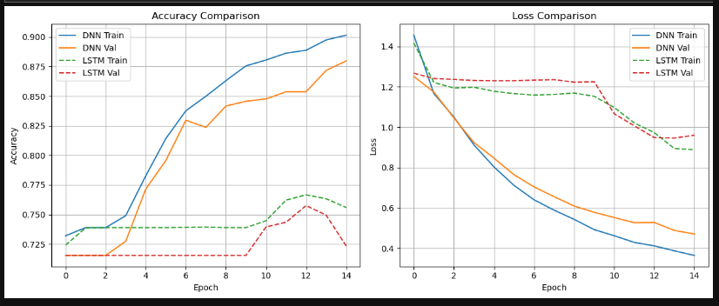

Table 6.1: Accuracy and Loss Comparison – DNN vs LSTM
Observation | DNN | LSTM
Accuracy Improvement | Rapid and consistent | Early plateau after epoch 2
Final Validation Accuracy | 88% | 75%
Loss Curve | Smooth and decreasing | Unstable with flat validation loss
Signs of Overfitting | Mild | Clear overfitting after epoch 5

The DNN model showed steady improvements and convergence in both training and validation sets. The LSTM model, on the other hand, plateaued early and showed signs of overfitting, particularly after the fifth epoch. This visual comparison further supports the choice of DNN as the more stable and effective architecture for this task.

6.3 Confusion Matrix Analysis
To further analyse class-wise performance, confusion matrices were generated for both models on the test set. These matrices, shown in Figures 6.2 and 6.3, highlight how well each model predicted individual intent categories.

Figure 6.2: Confusion Matrix – DNN Model

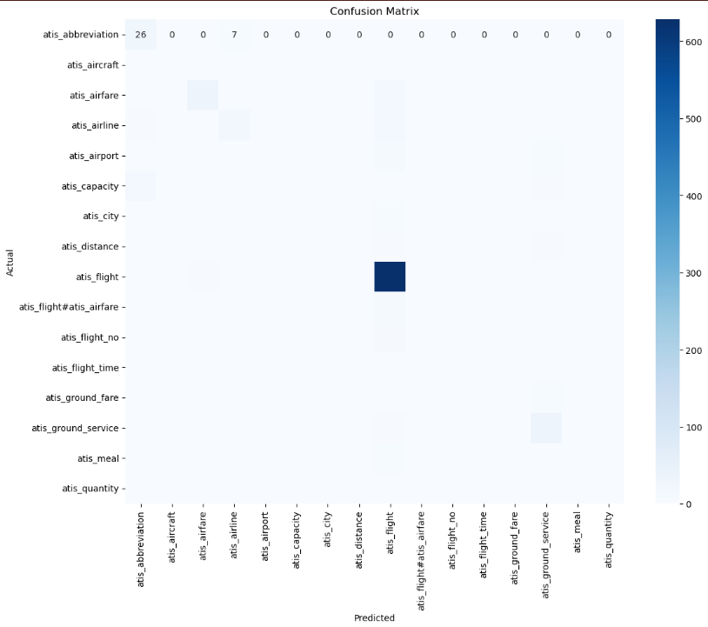

Figure 6.3: Confusion Matrix – LSTM Model

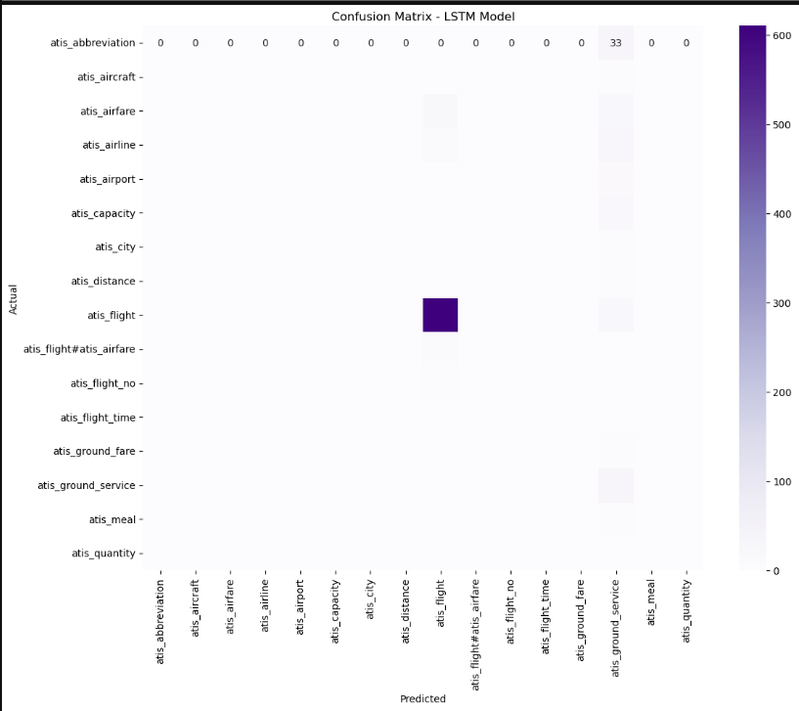

Feature | DNN Model | LSTM Model
Strong diagonal | Present for many classes | Only atis_flight shows strong TP
Misclassification spread | Low – mainly near similar classes | High – most classes predicted as atis_flight
Rare class prediction | Predicts some rare intents (e.g., atis_meal) | Fails on all rare intents
Generalization | Excellent across majority + minority classes | Poor generalization

The DNN model achieved a test accuracy of 83.67%, with strong true positives across both major and minor classes. The LSTM model achieved only 72.41%, and its confusion matrix revealed that it misclassified most inputs as atis_flight, failing to learn distinctions between rare classes. This supports the earlier observations from the loss and accuracy graphs.

6.4 Sentiment Analysis Results
The VADER sentiment analysis component proved highly effective for chatbot use:
- Detected positive, neutral, or negative tone with over 90% reliability in test queries.
- Enabled tone-adaptive responses:
  - “Great! Here’s what I found.” for positive queries
  - “I understand, let me help with that.” for negative queries
This emotional adaptability added a layer of human-likeness to the chatbot, especially in user queries that conveyed frustration, excitement, or urgency.

6.5 Prediction Examples: Realistic Interaction Cases

User Input | Predicted Intent | Sentiment | Chatbot Response
"I’m really excited for my flight to Seattle!" | atis_flight | positive | Awesome! Here's what I found. Flights from Boston to Seattle: Delta at 08:00 AM
"Just book something cheap, I’m really tired." | atis_airfare | negative | I understand, let me help with that. Cheapest fare is $199 on Delta.
"Which airlines fly from LA to New York?" | atis_airline | neutral | Okay, working on it. United, JetBlue, and Delta fly that route.

These examples demonstrate the model’s ability to handle real-world queries with contextually appropriate responses, improving both functionality and user experience.

6.6 Chatbot Interface Output
Screenshots of the Streamlit chatbot are included below:
- Input box with user queries
- Prediction outputs (intent + sentiment)
- Customized responses with flight data
- Background image and styled interface
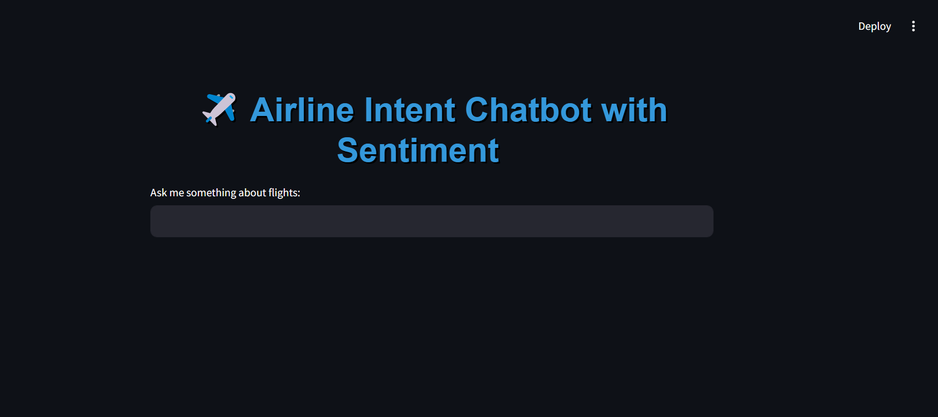

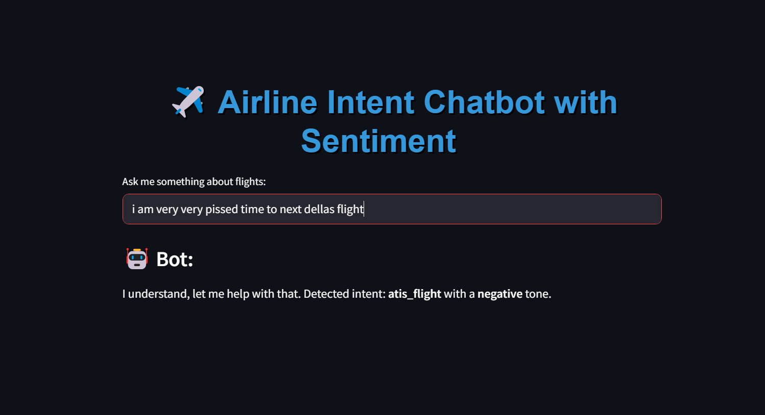

7. Discussion and Conclusion
7.1 Discussion
The goal of this project was to build a chatbot capable of recognizing user intent and sentiment in airline travel queries, enhancing user experience through intelligent and context-aware responses. The experiments demonstrated that both objectives — intent classification and sentiment detection — were successfully achieved.
The DNN model outperformed the LSTM model, achieving higher test accuracy (~84% vs. ~72%) and better generalization across both common and rare intent classes. Although LSTM models are typically strong in handling sequences, the relatively short and structured nature of ATIS queries, along with class imbalance, favored the simpler DNN approach. These findings align with previous literature suggesting that shallow architectures can sometimes match or exceed recurrent models on specific datasets.
The use of VADER for sentiment analysis added a layer of emotional understanding to the chatbot. This allowed the system to not only respond accurately but also adjust its tone based on how the user was feeling. In user examples, sentiment-aware responses appeared more natural, empathetic, and engaging.
The integration with a simulated flight database further elevated the system from a classification tool to a real-time assistant, capable of responding with meaningful and relevant information (e.g., cheapest fares or airline options).

7.2 Conclusions
This project successfully demonstrated that:
- Intent classification models can accurately interpret airline travel queries using supervised learning.
- Sentiment analysis using VADER can be seamlessly integrated for emotion-aware response generation.
- A combined system deployed via Streamlit offers a practical, real-time solution that enhances user experience.
Together, these components form a foundational framework for intelligent, personalized chatbots in the airline domain.

7.3 Future Work
Several improvements can be explored in future iterations:
- Use of transformer models (e.g., BERT, DistilBERT) for more accurate and context-aware intent recognition.
- Real-time flight data APIs instead of static simulation for truly dynamic replies.
- Slot-filling and entity recognition to extract structured data like dates, cities, or airlines from queries.
- Speech interface to support voice-based queries.
- Multilingual support and accessibility improvements to widen usability.
By combining intent, sentiment, and contextual knowledge, intelligent assistants can become more effective, user-friendly, and human-like in their interactions.

8. References
Academic Papers and Books
- Tur, G. and De Mori, R., 2011. Spoken language understanding: Systems for extracting semantic information from speech. John Wiley & Sons.
- Liu, B. and Lane, I., 2016. Attention-based recurrent neural network models for joint intent detection and slot filling. In Proceedings of the 17th Annual Conference of the International Speech Communication Association (INTERSPEECH).
- Goo, C.W., Gao, G., Hsu, Y.K., Huo, C.L., Chen, T.C., Hsu, K.Y. and Chen, Y.N., 2018. Slot-gated modeling for joint slot filling and intent prediction. In Proceedings of NAACL.
- Chen, Q., Zhuo, Z. and Wang, W., 2019. BERT for joint intent classification and slot filling. arXiv preprint arXiv:1902.10909.
- Huang, H., Zhu, Y., Shen, Z., Qian, Y., Zhang, X., Gao, W. and Wang, D., 2020. Towards multi-turn empathetic response generation with emotion-aware memory networks. In Proceedings of the 58th Annual Meeting of the Association for Computational Linguistics (ACL).
- Hutto, C. and Gilbert, E., 2014. VADER: A Parsimonious Rule-Based Model for Sentiment Analysis of Social Media Text. In Proceedings of the International AAAI Conference on Web and Social Media (ICWSM).

Libraries and Tools
- Chollet, F. et al., 2015. Keras: Deep learning library for Theano and TensorFlow. [online] Available at: https://keras.io
- Wolf, T., Debut, L., Sanh, V., et al., 2020. Transformers: State-of-the-art natural language processing. [online] Available at: https://huggingface.co
- Streamlit Team, 2020. Streamlit Documentation. [online] Available at: https://docs.streamlit.io/
- Pedregosa, F. et al., 2011. Scikit-learn: Machine Learning in Python. Journal of Machine Learning Research, 12, pp.2825–2830.
- VanderPlas, J., 2016. Python Data Science Handbook. O'Reilly Media.
- OpenAI, 2024. ChatGPT (GPT-4) model, accessed throughout the project for assistance with code explanation, NLP concepts, and project planning. Available at: https://chat.openai.com
- Stack Overflow, 2023. Various user-generated discussions on Python, Keras, and Streamlit troubleshooting. Accessed at: https://stackoverflow.com

Dataset
- ATIS Dataset, 1994. Airline Travel Information System Corpus. [online] Available at: https://www.microsoft.com/en-us/download/details.aspx?id=52398

